**MP Runbook for 7mode to CDOT MTT Migrations**

This document covers traditional xProfessional MP (multi-protocol) 7mode vfiler to CDOT vserver migration pre-work and cutover work. It does not address xMarkets 7mode usermap.cfg to CDOT mappings at this time.

**PRE-WORK:**

1) If not already done, make a BANANA request for new CDOT vserver and gather IP, netmask, and gateway information. Be sure VLAN for CDOT vserver is same VLAN as source 7mode vfiler or is new VLAN that will work with VLAN of source 7mode vfiler.

2) Create vserver in WFA by selecting Generic MP (NFS/CIFS) workflow from dropdown. **This is imperative to a successful cutover.**

Select “TR CDOT Create Vserver Only” workflow from “No Category” portal within WFA.

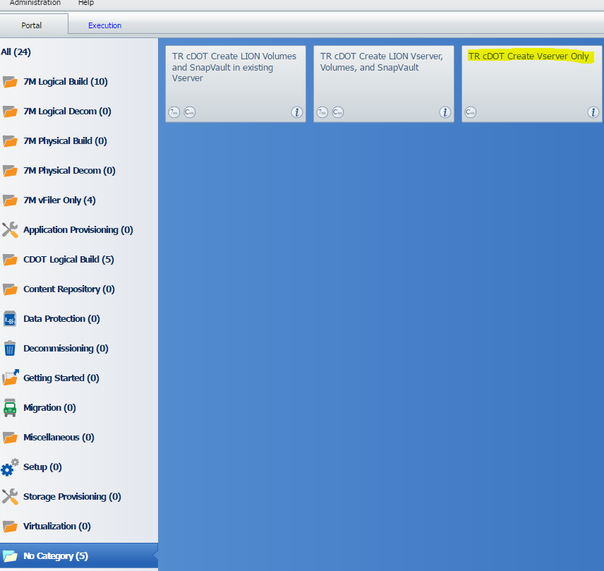

Fill out required fields and for “Vserver Type:” select “Multiple Protocol NFS/CIFS” from dropdown. “CIFS Server Domain:” will be the same CIFS domain that 7mode vfiler is using, eg. TLR.

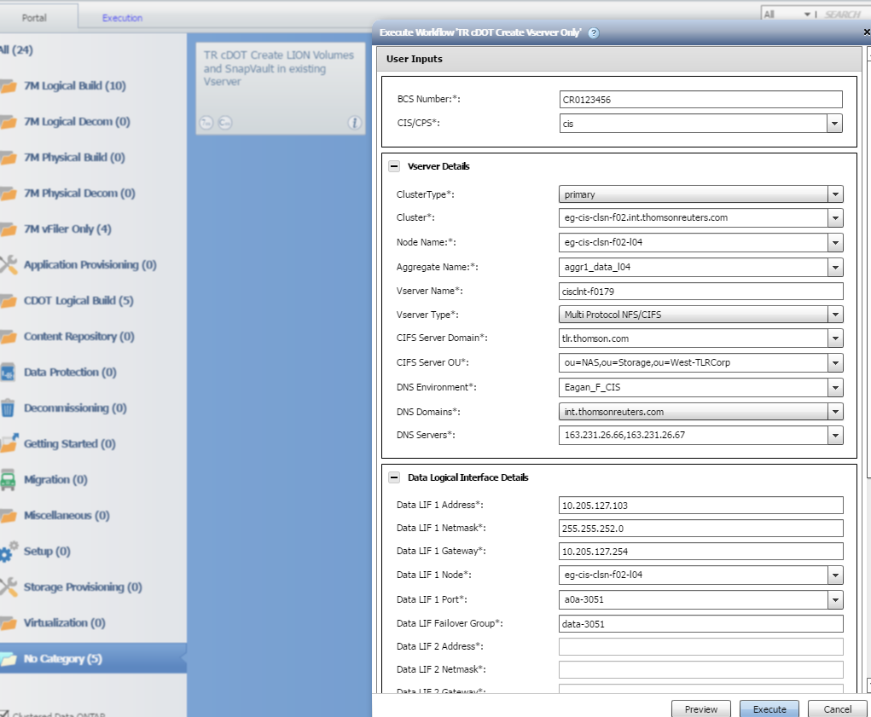

3) Enable CDOT vserver for AV (anti-virus) scanning.

a) vserver vscan scanner-pool apply-policy -vserver <CDOT vserver> -scanner-pool Active-Vscan-Pool -scanner-policy primary 

b) vscan enable -vserver <CDOT vserver>



c) vscan show -vserver <CDOT vserver>

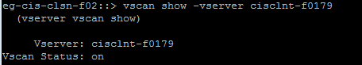

|  |  |
| --- | --- |
| 4) Disable NFS qtree export validation on CDOT vserver. (At some point this step will be incorporated into all WFA vserver workflows.)  a) set -privilege advanced |  |
| b) vserver nfs modify -vserver <CDOT vserver> -validate-qtree-export disabled |  |
| c) vserver nfs show -vserver <CDOT vserver> -fields validate-qtree-export |  |
| d) set -privilege admin |  |

5) Modify DNS Domains list on CDOT vserver to include host domain suffixes if different from vserver DNS.

a) dns modify -vserver <CDOT vserver> -domains <domain suffixes, comma separated>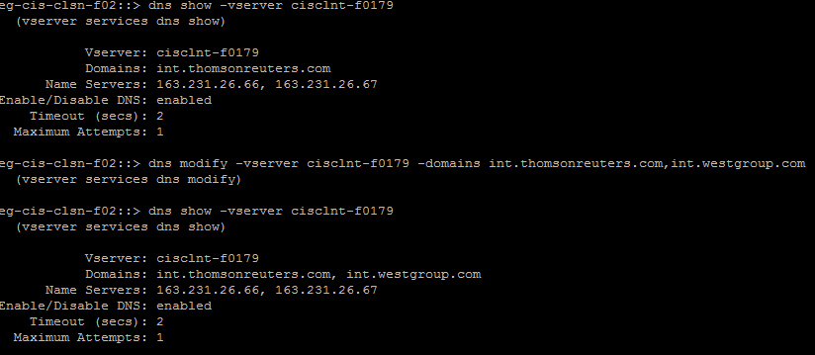

6) Check ZIPPER for any CNAME aliases for 7mode vfilers. (Prior to cutover, you will need to open BANANA requests to FLS-NETWORKS to remove CNAME from 7mode vfiler and to add to CDOT vserver.)

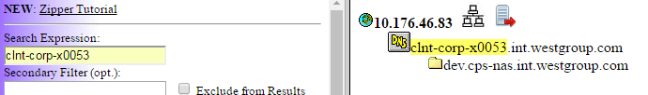

7) Start MTT snapmirror migration between source 7mode vfiler and destination CDOT vserver. Follow standard process until you get to MTT screen below. Select CIFS and NFS options as shown – **Exception:** DO NOT select Netgroups

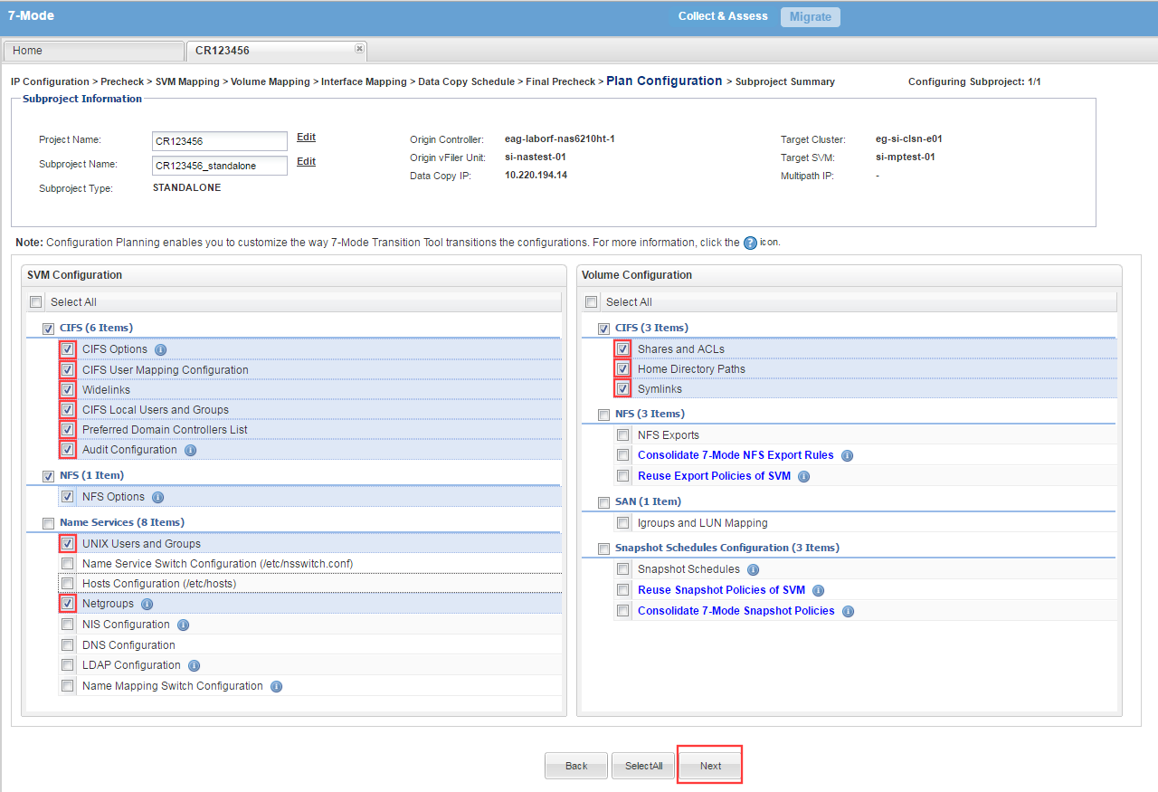

8)

8) Create post-MTT Cheatsheet as per standard process.

**CUTOVER WORK:**

1) At start of migration, on source 7mode vfiler, run “cifs sessions”. Verify which volumes with CIFS shares are migrating and which are not. If all volumes with CIFS shares are migrating and there are active “cifs sessions”, notify PM to get confirmation from BU that you will be terminating CIFS sessions. If only some CIFS volumes are migrating, then you will need to terminate CIFS at the volume level for each volume migrating. This has to be done in “privilege advanced” mode on 7mode vfiler.

a) cifs terminate 🡪 use if all CIFS volumes are migrating

b) priv set advanced

cifs terminate -vol <7mode volume> 🡪 use if only some CIFS volumes are migrating

2) Review PRE-WORK Step 6 above. If any CNAME aliases to cutover, please coordinate timings with FLS-Networks to complete Step 6 requests after Storage Cutover Task, prior to handing off to UNIX for remounts. Include FLS-Networks on Migration email chain.

3) At Storage Cutover task, run MTT cutover per standard process.

4) Complete Cheatsheet per standard process, configuring policies, snapshot/snapvault schedules, etc. Note: DO NOT delete default export-policy rule for CIFS protocol.



5) Before handing over to UNIX team for remounts, work with FLS-Networks to complete CNAME moves to CDOT vserver, if any discovered during PRE-WORK Step 6. Offline/Rename source 7mode volumes.

**POST-WORK:**

1) Verify CIFS is active on CDOT vserver

a) cifs show -vserver <CDOT vserver>

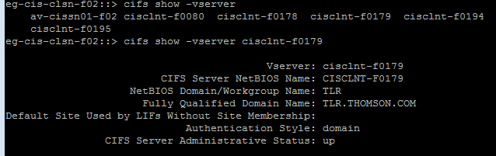

2) Verify AV scanning is active on CDOT vserver

a) vscan show -vserver <CDOT vserver>

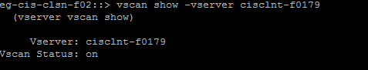

3) Verify CIFS shares were migrated to CDOT vserver

a) cifs share show –vserver <CDOT vserver>

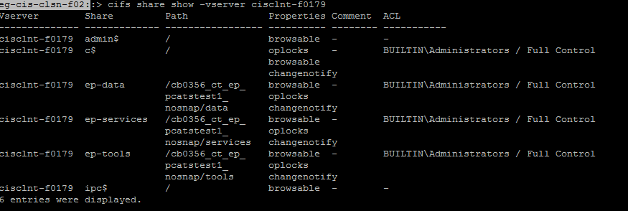

4) Verify members of local-groups on CDOT vserver.

a) users-and-groups local-goup show-members -vserver <CDOT vserver>

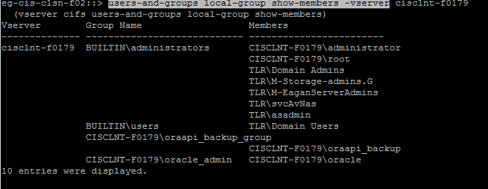

5) Verify UNIX team(s) are good with UNIX mounts and BU can access CIFS shares using CDOT vserver FQDN or IP.